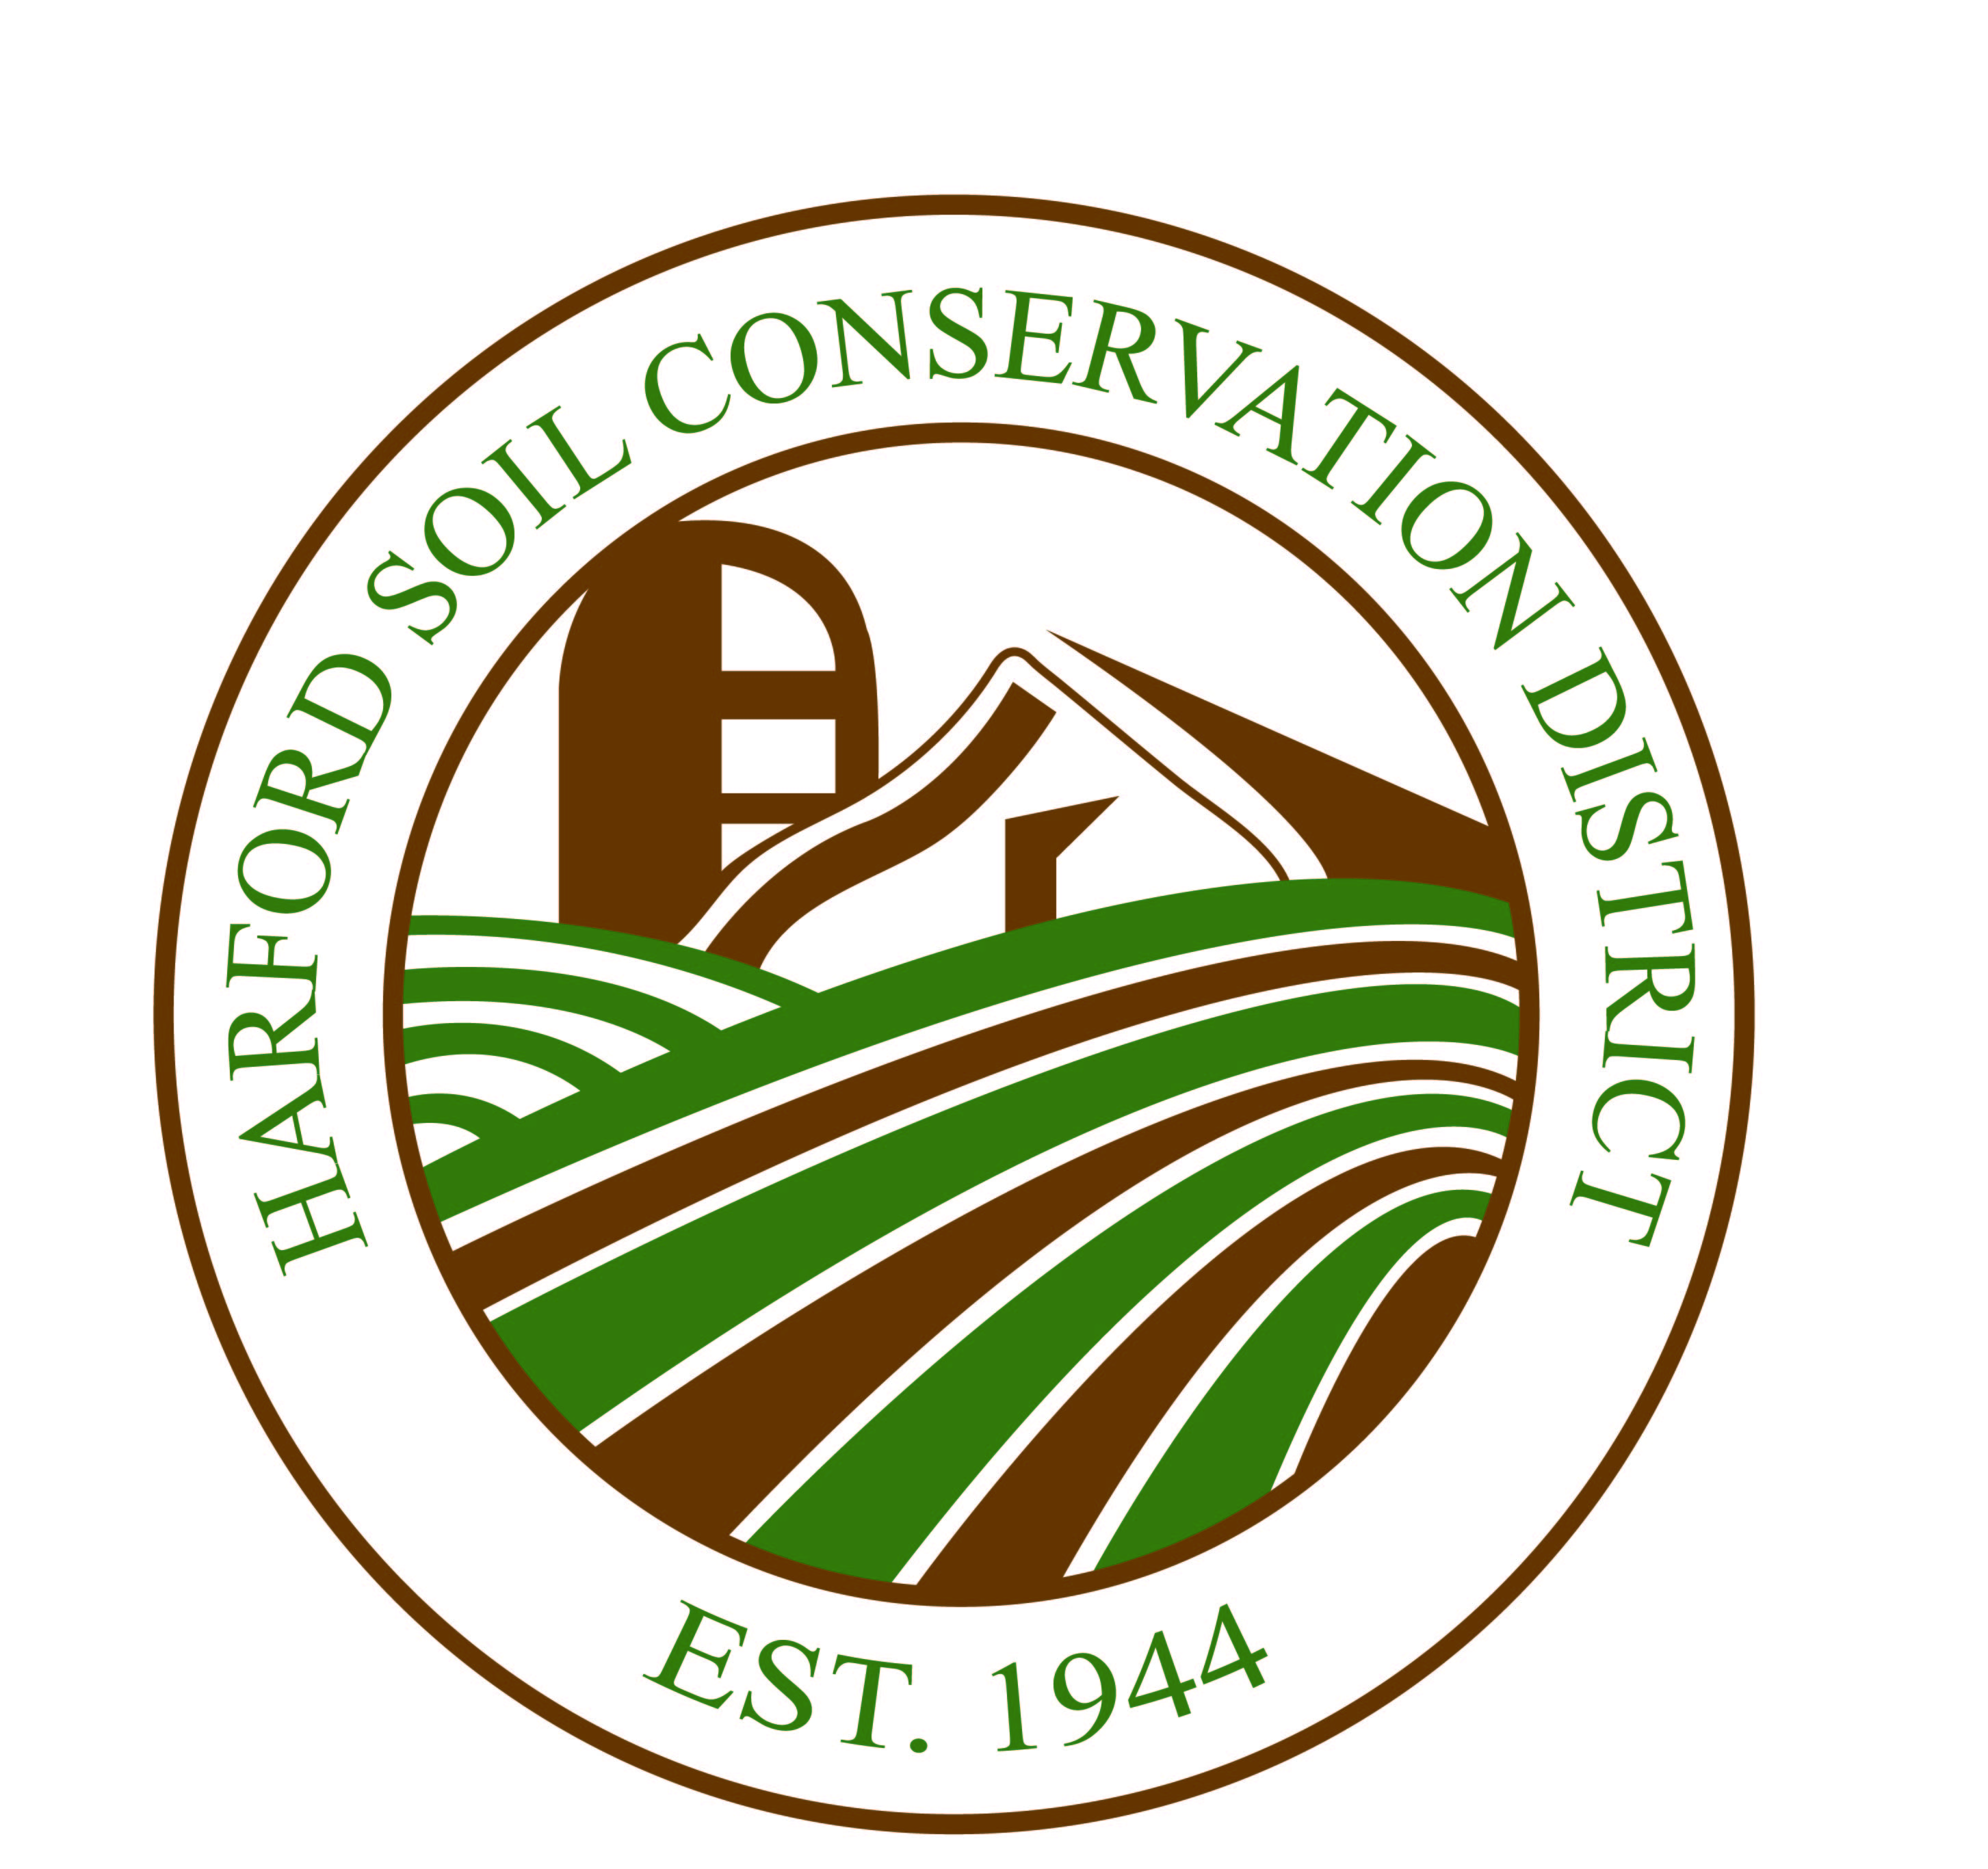
Harford Soil Conservation District
2205 Commerce Road Suite C Forest Hill, Maryland 21050 (410) 838-6181, Ext. 3 www.harfordscd.org

Board of Supervisors Meeting

DRAFT AGENDA

***May 11, 2017***

- Call to Order

- Approval of Agenda

- Public Comments

- Approval of the Meeting Minutes from April 13, 2017

- Treasurer’s Report for April

- Correspondence

- Old Business

    - District Conservationist’s (DC) Report
    - District Manager’s (DM) Report
    - Conservation Tracker Update
    - Grant Programs Update
    - Extension Report
    - Other

VIII. New Business

    - Other

IX. Next Board Meeting

Our Mission

The mission of the Harford Soil Conservation District is to provide all sectors of the County with technical, planning and design assistance for land management decisions; to promote an array of Best Management Practices to protect and conserve the natural resources within the Chesapeake Bay Watershed; and to educate students, farmers, developers and landowners on soil erosion and water quality improvement efforts.

